





SHA-256 in Action – Cryptographic Hashing

Objective/Aim:
To understand and implement the SHA-256 cryptographic hashing algorithm, observe its properties, and analyze its output on different input data.

Apparatus/Software Used:
- Laptop/PC
- PowerPoint/Word for documentation
- Internet for research

Theory/Concept:

A blockchain is a distributed, decentralized digital ledger that stores information in blocks. Each block contains:
- Data (transaction or record)
- Timestamp
- Previous Hash
- Current Hash
The integrity of the blockchain is maintained using hashing algorithms, usually SHA-256. Hashing converts input data into a fixed-length string of characters, which is unique to that input.
Creating and hashing your first block is a foundational step to understanding how blocks are chained and how tampering is prevented.

Procedure:

- Open a web browser and go to the Blockchain Demo website.
- Navigate to the “Blockchain” section.
- Observe the first block (Genesis block) with default values.
- Modify the data in a block and notice how the hash changes.
- Observe how each block contains the hash of the previous block, creating a chain.
- Try changing data in a block and see how it breaks the chain (hash mismatch).
- Click “Mine” to recalculate hashes and restore the chain.
- Understand how blockchain maintains data integrity and immutability through hashes.
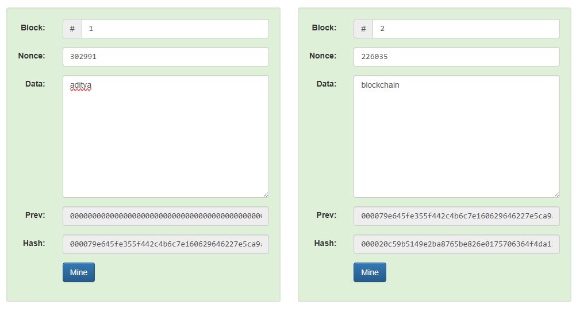

Observation Table:
Action | Input data | Hash output | Observation
Initial block | First block | SHA256 hash | Unique hash generated
Second block | Second block+ Prev Hash | New SHA256 hash | Changes as previous hash changes
Data modification | Change block data | New SHA256 hash | Hash completely changes

